14/2/2023

Assignment 1

Data Visualisation

Lucy Coldridge

Just IT

Contents

Contents 1

Scenario 2

Task 1: Policies and Procedures 2

Task 2: Excel – ‘The Wealth of Nations’ Data 3

Task 3: Tableau – ‘The Wealth of Nations’ Data 11

Tutor Feedback.………………………………………….…… 18

Summary 18

**Scenario**

Look at the data workbook and familiarise yourself with this data. Create a visual report that will show the data in the form of charts and maps using Tableau to the client’s requirements. Consider data protection and computer misuse policies.

**Task 1: Policies and Procedures**

**Objective:** Outline what policies need to be adhered to when working with data. Investigate by researching the internet or looking back at your notes to tell us what and why these policies need to be adhered to while using the ‘The Wealth of Nations’ data. Also tell us why it is important to be aware of these rules as a data analyst.

**The Data Protection Act 2018 (UK’s implementation of the General Data Protection Act (GDPR)**

Personal data such as names, addresses, credit history, medical conditions, contact information etc, is all stored in databases and is classed as sensitive data.

This type of data is important to keep confidential to avoid crimes being committed, such as phishing, hacking, scams, identify theft etc.

When working with any data as an analyst, you have to ensure it is:

* Used fairly and lawfully for specified purposes.
* Used in a way which is necessary.
* Kept to date and accurate.
* Kept no longer than necessary.
* Handled with security.

**The Computer Misuse Act 1990**

The Computer Misuse Act protects personal data from unauthorised modifications and access. A data analyst needs to know it is illegal to:

* Enter a computer system without permission, also known as hacking.
* Enter a computer system to steal data or destroy a device, also known as a virus.
* Deleting or modifying data.
* Planting malware or spyware on a computer system, also known as theft of information.
* Using, making or sharing anything which can be used in computer misuse offenses.

If these laws are broken, you can face a fine or imprisonment.

**Task 2: Excel – ‘The Wealth of Nations’ Data**

**Objective 1:** Set a password to protect the workbook.

I set a password on my workbook by clicking *File > Save as > Tools > General Options > Entering and confirming passwords > OK.*

**Objective 2:** Highlight column C and change the data to display in British Pound symbol.

I changed the currency by selecting the *C column > Right click > Format cells > Number tab > Currency > Symbol (£).*

**Objective 3:** Turn the GDP sheet into a table.

I turned my GDP sheet into a table by *highlighting columns A-D > Insert > Table icon > Create Table from selected cells > Checking my table has headers > OK.*

**Objective 4:** Filter the table to display only the information for 2019.

To filter my table, I clicked the *dropdown arrow next to ‘Year of Information’ > Unchecked (Select All) > Checked ‘2019 > OK.*

**Objective 5:** Create a chart displaying the data ‘Rank, Country and GDP – per capita (PPP).

I created a chart based on my table by *highlighting columns A-C > Insert > Charts icon > 2-D Column.*

**Objective 6:** Using your creative skills, edit the chart. Add a title, X and Y axis labels and make the chart visually pleasing.

I added different chart elements, such as axis titles, a chart title, gridlines, legend etc by selecting *Chart Design > Add Chart Element icon > selecting the different options.*

I then changed the visuals of my chart by *double clicking the chart > Format Chart Area > Gradient stops & borders.*

**Objective 7:** Move the chart to a new sheet tab and label with a suitable name.



I created a new worksheet by *clicking the ‘+’ > Right clicked the tab > Rename.*

**Objective 8:** Create a sort for the top 20 highest ranking countries.

I created a sort for the top 20 countries by *clicking the dropdown arrow next to ‘GDP – per capita (PPP)’ > Number Filters > Top 10… > Changed value from 10 to 20 > OK.*

**Objective 9:** Create a new bar chart to display the top 20 from the sort and place with the table.

I created a bar chart based on my table by *highlighting columns A-C > Insert > Charts icon > 3-D Column.* I decided to use a different colour scheme and add elements. I did this by *clicking the ‘+’ next to my bar graph > Chart Elements > Selecting axis titles, chart title, data labels, gridlines.*

**Objective 10:** Colour the background with the ‘add a fill colour’ icon and select

colour.

I changed my background colour by *highlighting the cells behind my table and bar chart > Click the fill icon > Select colour,*

**Objective 11:** Create 3 macro buttons, print, save and copy the sheet.

For my buttons, I used images to make them more interesting. I did this by *clicking Insert > Icons > Searching relevant icons > Select > Insert*

*** 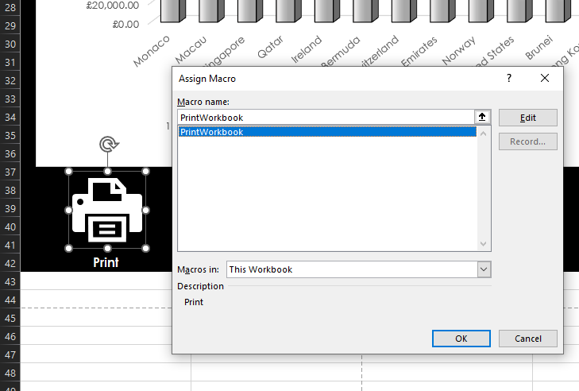

I then recorded my macros by *clicking View > Dropdown arrow on the Macros icon > Record Macro… > Name Macro > Add description > OK.*

Once recording I then went to *File > Print > Dropdown arrow on Macros icon > Stop recording.*

I then went to my Print icon and *right clicked > Assign Macro… > Selected PrintWorkbook > OK.*

I then took the same steps of recording and assigning macros for saving my workbook and copying my table and bar chart. I also tested my buttons when complete to make sure they were all working as planned.

**Objectives 12 & 13:** Using the copy macro, copy and paste into a Word document, keeping the formatting. Give the page a title and save your document as ‘Word Gross Domestic Product Report 1’.

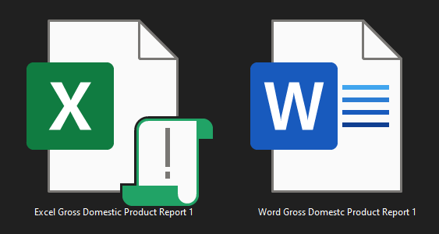

**Objectives 14-19:** Add a header and footer to your Excel table. In the header, enter your name and ‘GLA DATA 1’. In the footer, add today’s date, Assignment 1 and Data Visualisation. Save your Excel file and close Word document only.

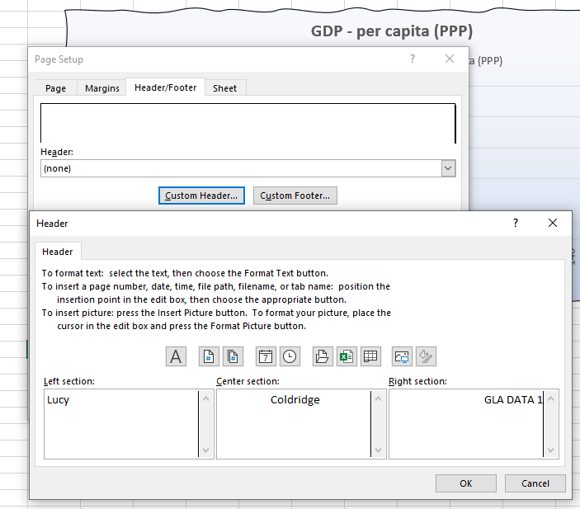

Header:

Footer:

To add my header and footer I went to *Page Layout > Page Setup > Header/Footer Tab > Custom Header & Footer > OK.*

I also tested another way to do this by *clicking the ‘page layout’ icon at the bottom right > Hovering over the boxes and entering my text* before going back to the ‘Normal View’ icon.

Finally, I saved my Excel document as instructed and closed my Word document only.

**Task 3: Tableau – ‘The Wealth of Nations’ Data**

**Client Requirements:** The client is colour blind and requested you to bear this in mind when building your dashboard. The client is only interested in the top 20 highest ranking countries which is what your visuals should show.

**Objective 1:** Import data.

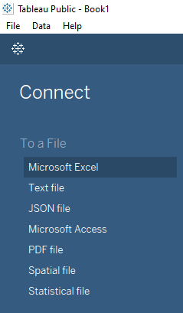

I imported the ‘The Wealth of Nations’ data by *opening Tableau >* *Clicking ‘Microsoft Excel’ in the ‘To a File’ section > Selecting the Excel dataset > Open.*

**Objective 2:** Set relationships.

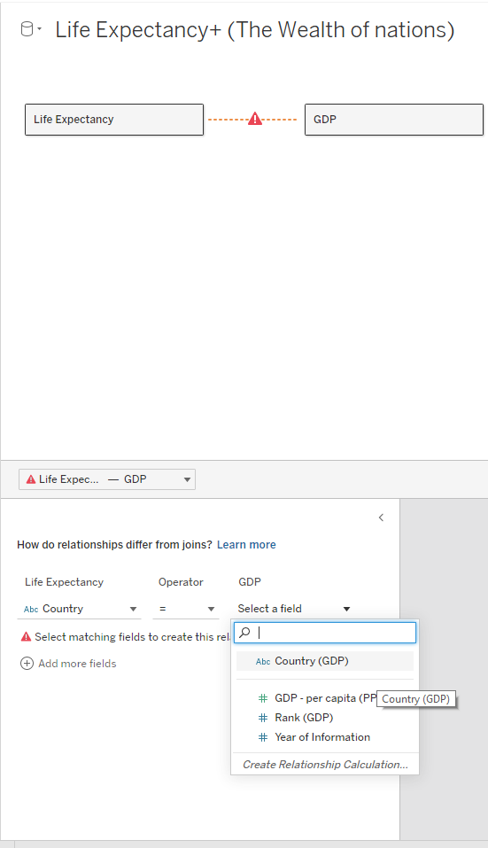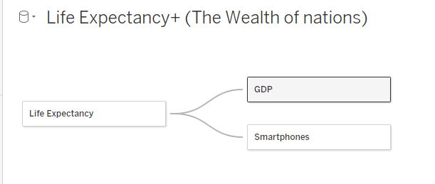

To set relationships, I *clicked and dragged the data sheets across > click the dropdown arrow of ‘Select a field’ > Select ‘Country/Country (GPD)’.*

**Objective 3:** Check data types.

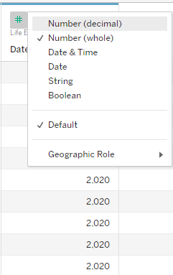 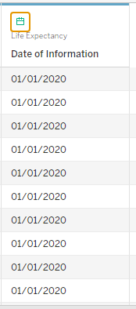

I noticed the ‘Date of information’ column was set to ‘Number’ so I decided to change it to ‘Date’. To do this, I *clicked the data type icon > selected ‘Date’.*

**Objective 4:** Build charts.

I went onto the ‘Sheet 1’ tab to create my first chart.

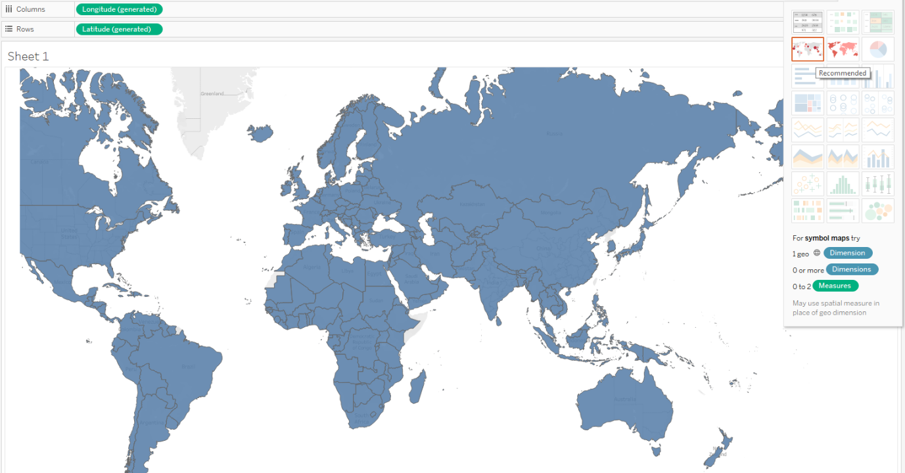I then *opened the ‘Life Expectancy’ field > Clicked and dragged ‘Country’ to the sheet > Selected ‘Maps’ chart type,* which changed my columns and rows shelves automatically to longitutde and latitude.

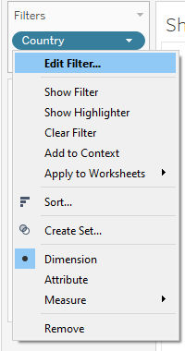 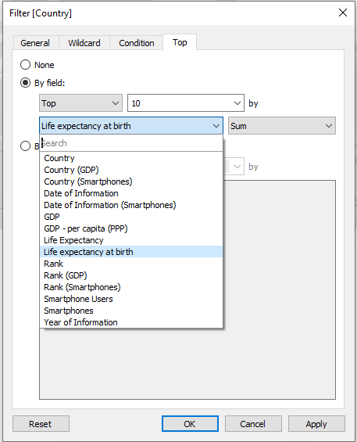

I then *dropped ‘Country’ into the ‘Filters’ shelf > Top tab > 20 > Selected ‘By field:’ > Selected ‘Life exp at birth’ > Apply > OK.*

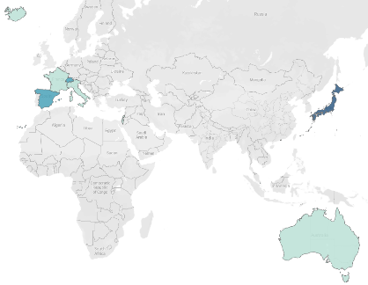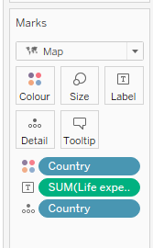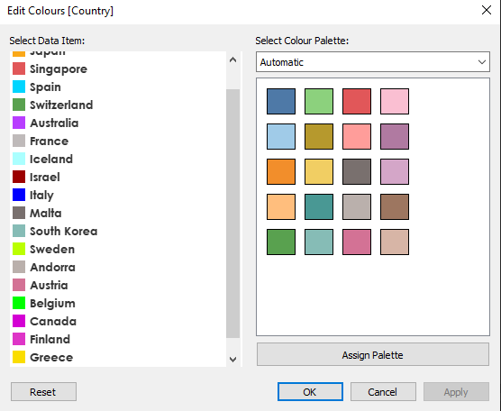

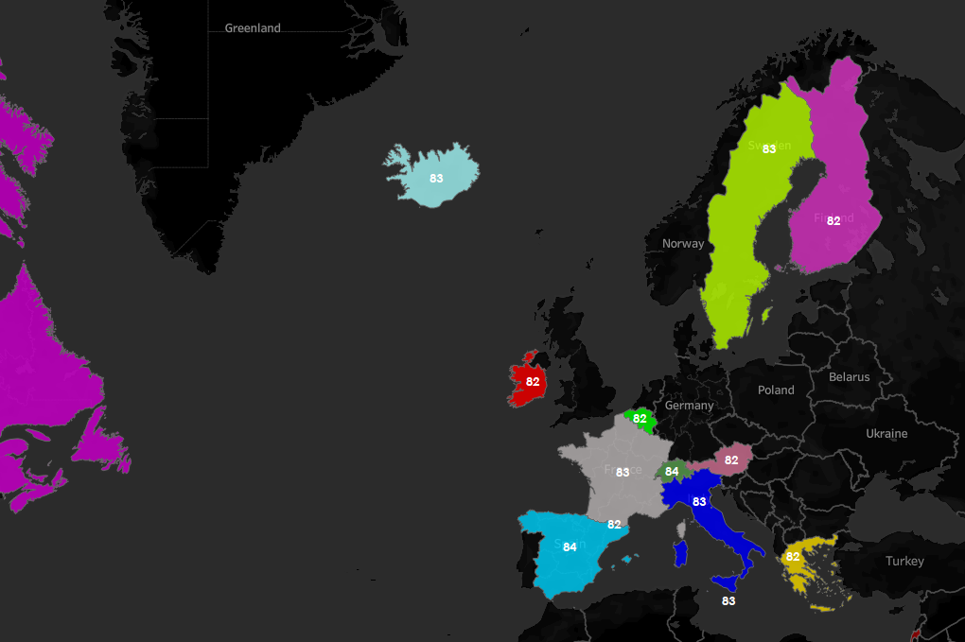

I then changed the colours of each country and the map, baring in mind the client is colourblind. I did this by *clicking the dropdown arrow next to countries in the right bar > ‘Edit Colours…’ > Double clicking a country and picking a colour > Apply > OK.*

To change the background colour of the mop to give more contrast, I *right clicked the map > Selected ‘Background Layers…’ > Clicked the dropdown arrow under ‘Style’ > Selected ‘Dark’.*

Finally, I renamed the chart tab to ‘Life Exp Map’ by *right clicking the ‘Sheet 1’ tab > Rename.*

**Objective 5:** Build your dashboard.

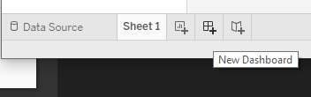

I then created my dashboard by *clicking the ‘New Dashboard’ button at the bottom* and creating the dashboard tab.

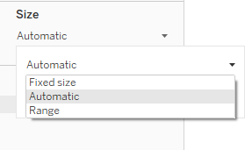

I changed the size of my dashboard to allow me to fit up to 4 charts. I did this by *clicking the dropdown arrow under ‘Size’ > Selecting ‘Automatic’.*

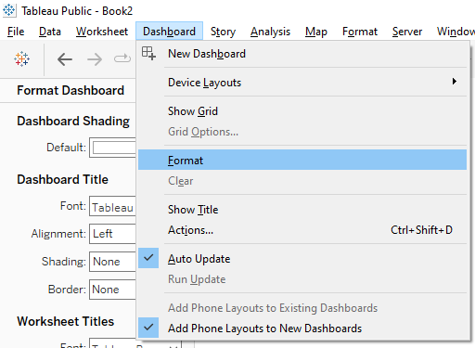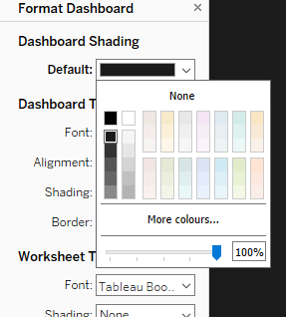

I then changed the colour of the dashboard background by *clicking ‘Dashboard’ > ‘Format’ > Default colour under ‘Dashboard Shading’ > Selecting colour.*

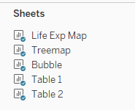

To add my new chart to the dashboard, I *clicked and dragged the required sheet (Life Exp Map) onto my dashboard.*

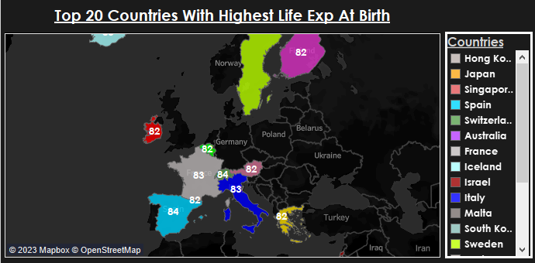I resized and arranged my chart where I wanted it on my dashboard, along with the legend of the countries next to it. To do this, I set my chart as ‘floating’ from tiled.

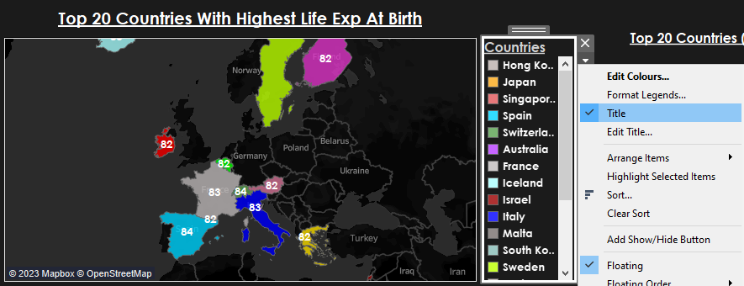

I then added a title to my chart by *clicking the dropdown arrow on the chart > Selecting ‘Title’ > Renaming to my desired title.*

I continued to make a further 3 charts, displaying different data and then renamed each tab.

Once I had placed all my charts onto my dashboard, I finally added a main title. To do this, I *clicked the ‘Text’ object.*

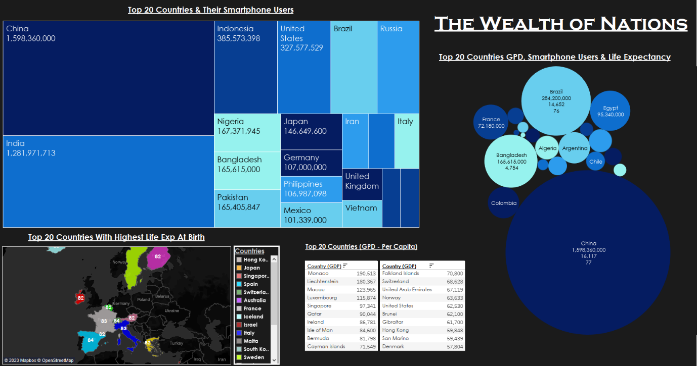I included a map, treemap, packed bubbles and two small text tables on my dashboard to showcase the data.

**Tutor Feedback**

Upon receiving feedback from my tutor, I decided to change the background colour of my dashboard from black to white. This gives more contrast with all the different shades of blue I used on my charts.

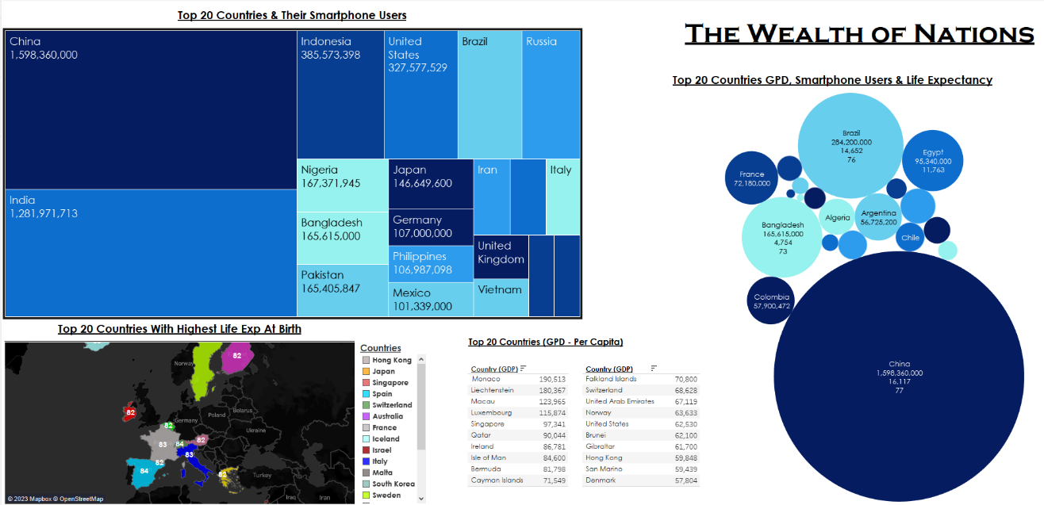

**Summary**

A reflective account to evaluate your project, including what went well and areas for development and lessons learned.

During this project, I learnt a lot more in-depth information about GDPR and The Computer Misuse Act, which I found to be very interesting. For example, I didn’t know that there were two types of personal data and the data these include. I also learnt more about using Tableau and the customisations available for your charts and dashboard.

I did, however, find it slightly difficult being able to add all my charts to my dashboard without it looking too squashed and overlapping, but I managed to find a way around this by maximising the dashboard size.

My favourite part of this project was actually all of it! I liked working with Excel and Tableau to make different charts and I loved documenting everything I was doing and slowly watching my work all piece together to make my final project.